|  |
| --- |
| **PHASE 2-PROJECT**  **FLY AWAY**  **AN AIRLINE BOOKING PORTAL**  **(Application Screenshots)** |

**Version History**

|  |  |
| --- | --- |
| Author | K.Swathi |
| Purpose | Screenshots of the Application |
| Date | 30/09/2021 |

**Main Folder 🡪 To create a new Dynamic Web Project 🡪 FlyAwayProject**

**1.com.database**

* **Dao.java**

**2.com.servlets**

* **AdminLogin.java**
* **FlightList.java**
* **ForgotPassword.java**
* **HomePage.java**
* **InsertFlight.java**
* **Logout.java**
* **UserLogin.java**
* **UserRegistration.java**

**3.com.util**

* **stringUtil.java**

**4.Web-Inf🡪 Lib**

* **adminhome.jsp**
* **adminpage.jsp**
* **bookflight.jsp**
* **flightlist.jsp**
* **forgotpassword.jsp**
* **homepage.jsp**
* **userpage.jsp**
* **userregistration.jsp**

**Project Explorer Screenshots**

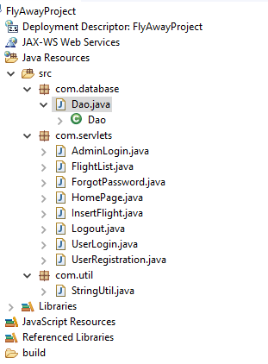

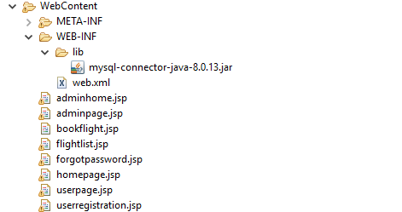

**Project screenshots - Main Folder 🡪 To create a new Dynamic Web Project 🡪 FlyAwayProject**

**1.com.database**

**Dao.java**

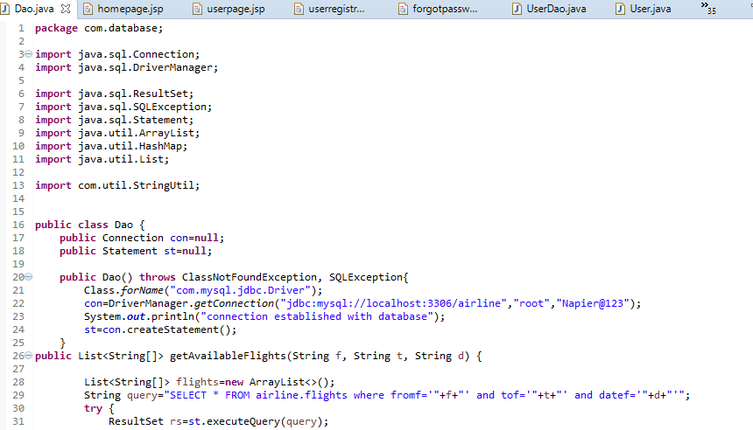

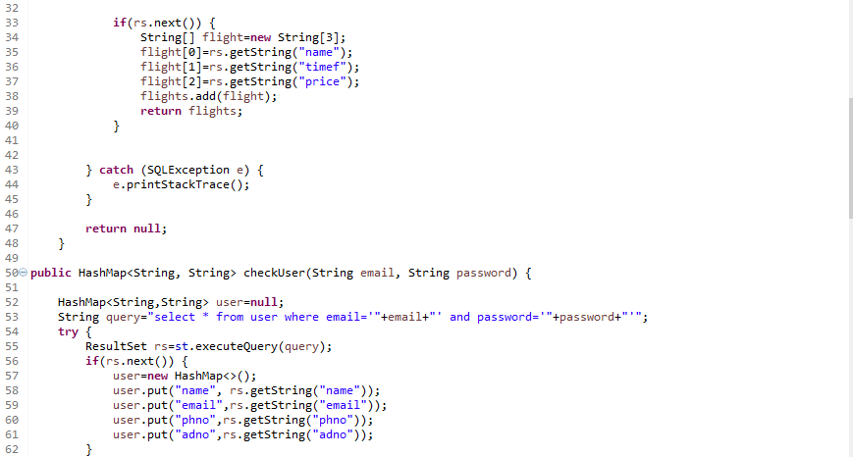

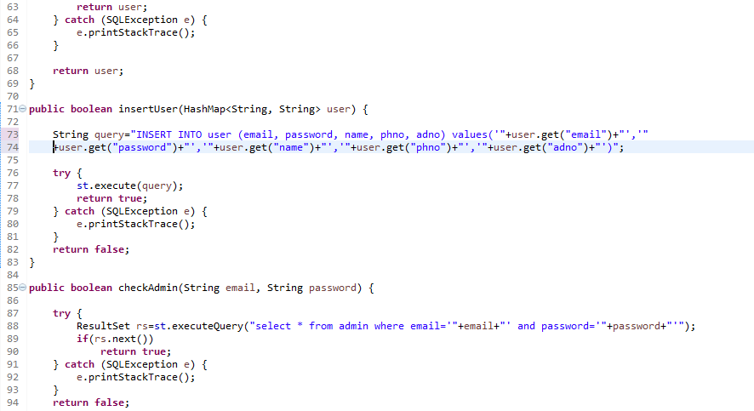

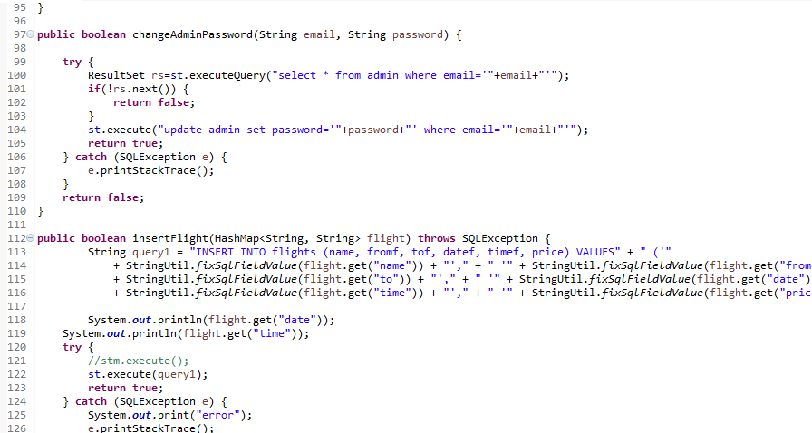



**2)Com.Servlets**

**AdminLogin.java**

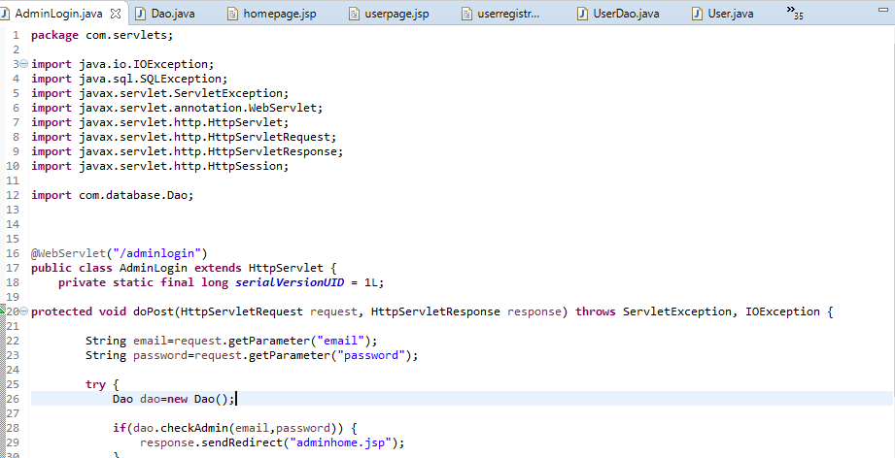

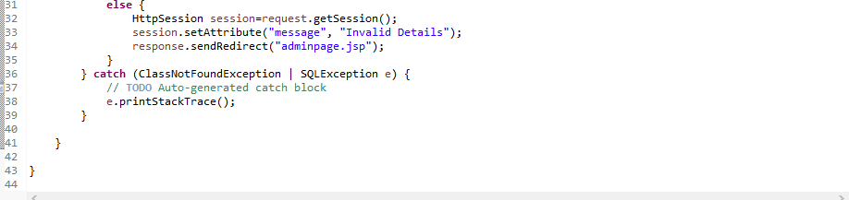

**FlightList.java**

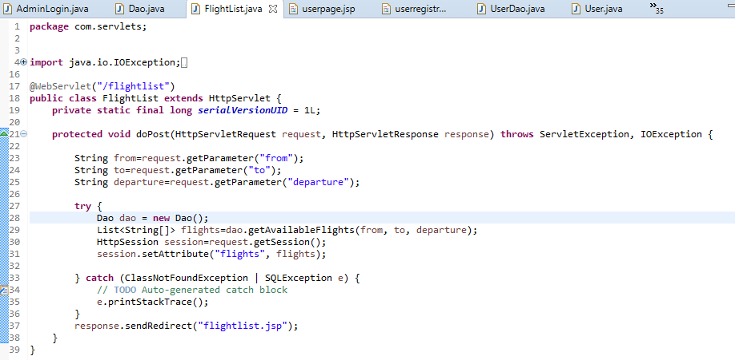

**ForgotPassword.java**

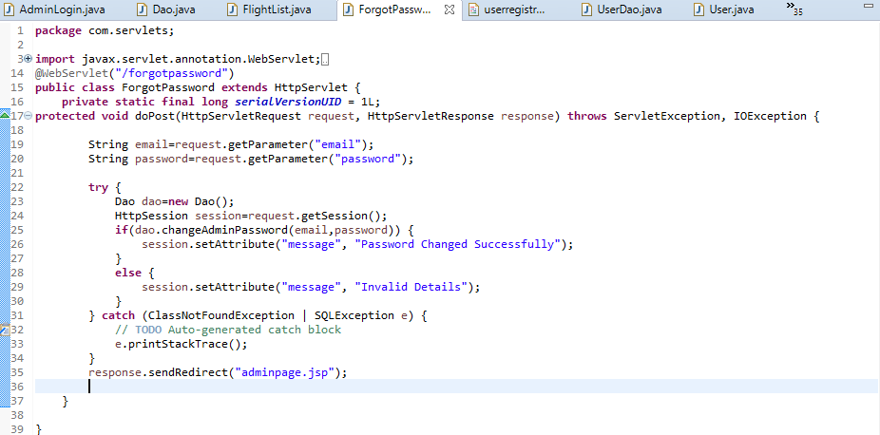

**HomePage.java**

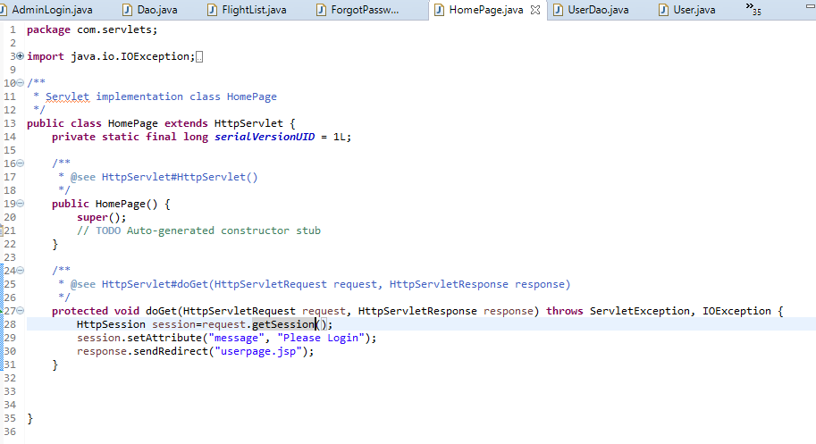

**InsertFlight.java**

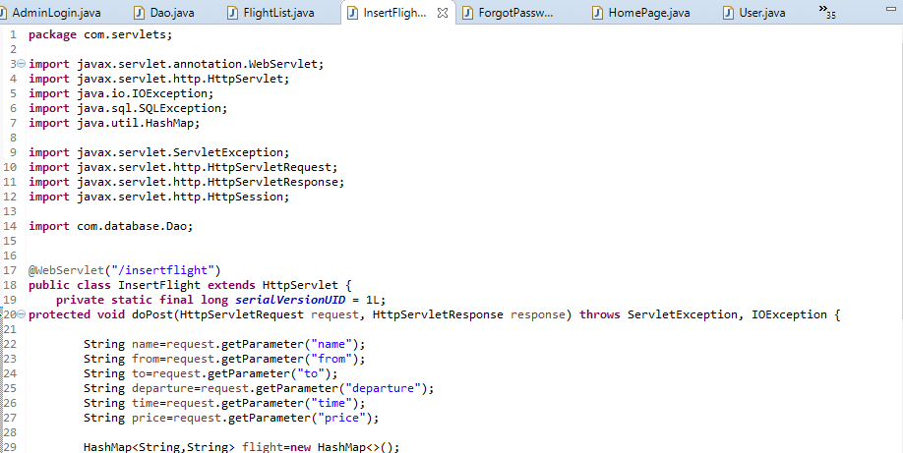

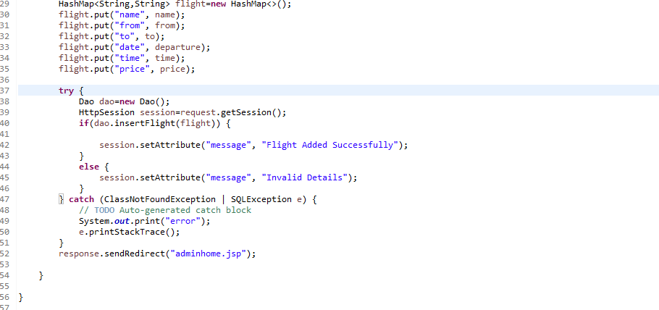

**Logout.java**

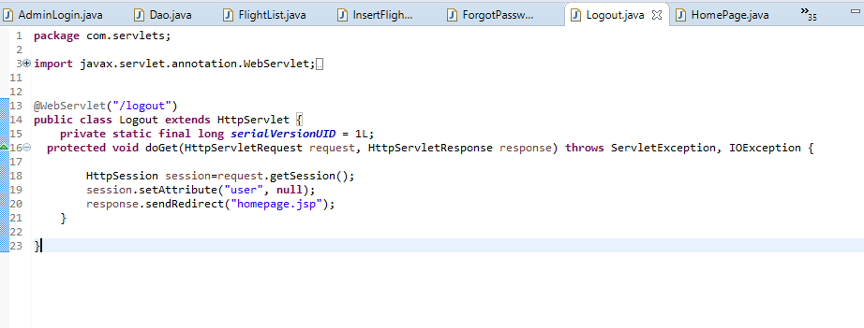

**UserLogin.java**

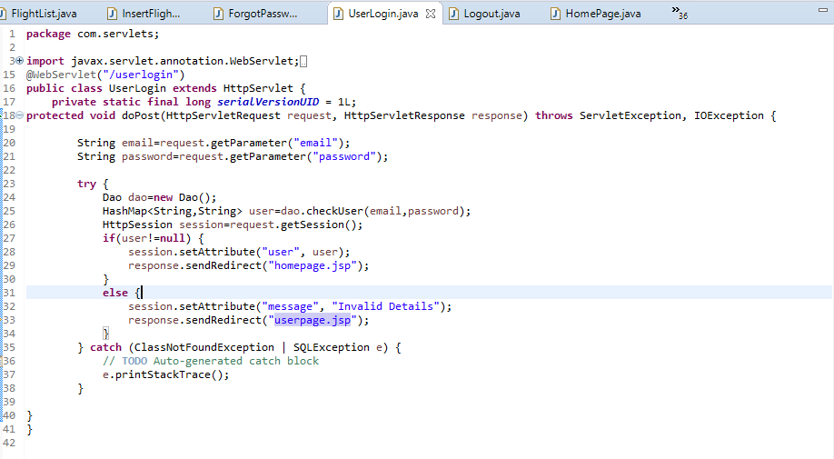

**UserRegistration.java**

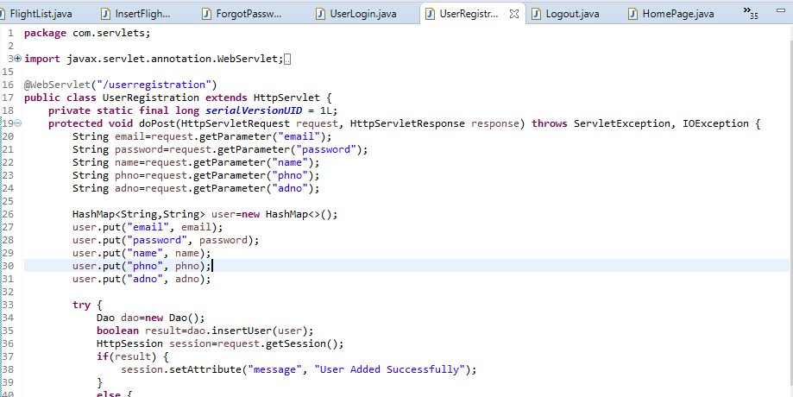

**3)com.util**

**StringUtil.java**

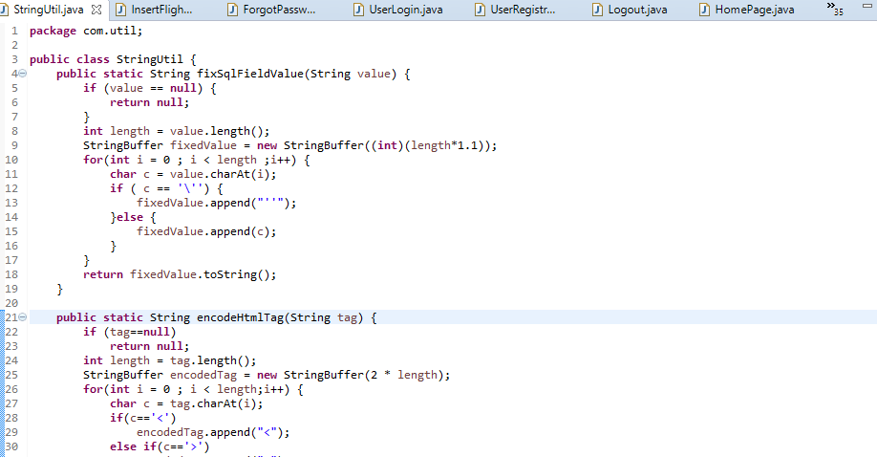

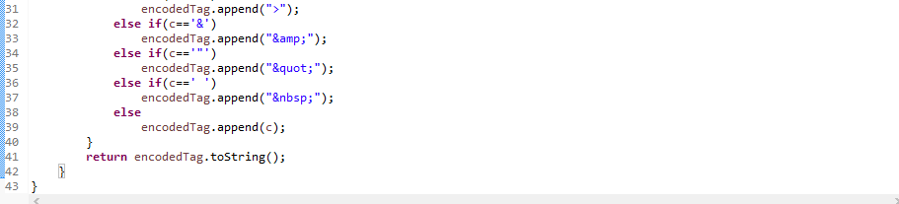

**4)Web-Inf🡪Lib**

**Web.xml**

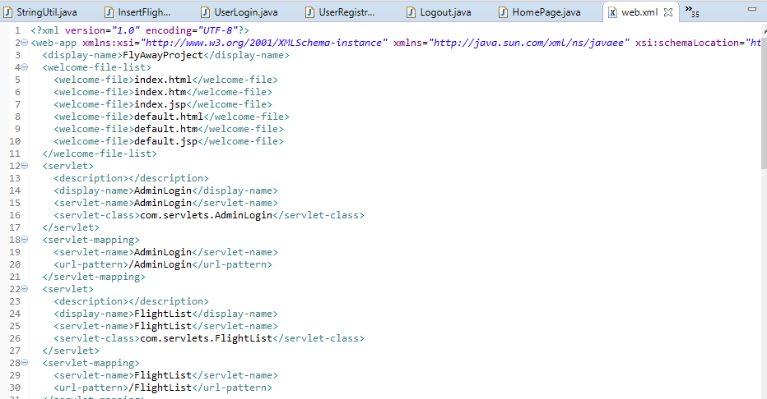

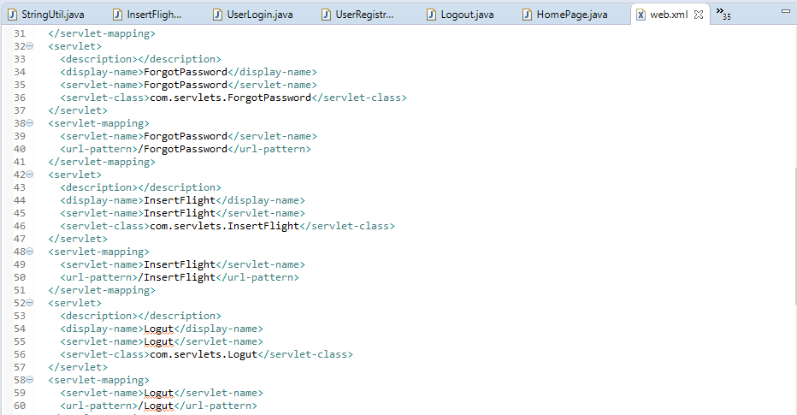

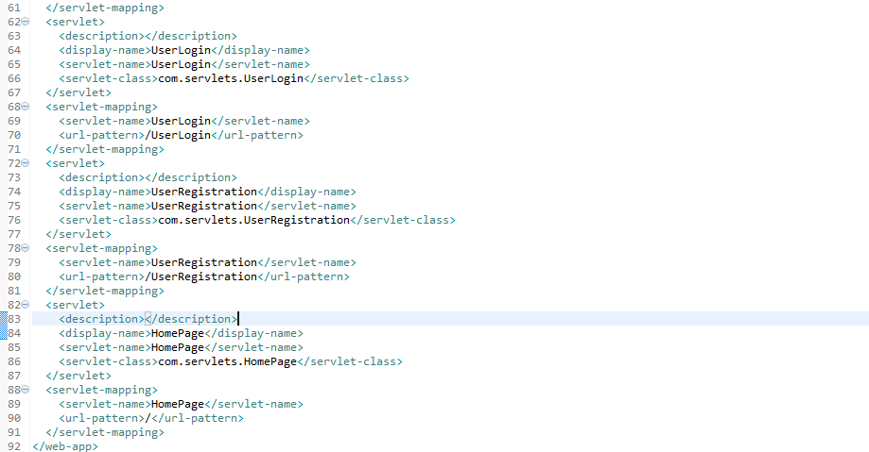

**Adminhome.jsp**

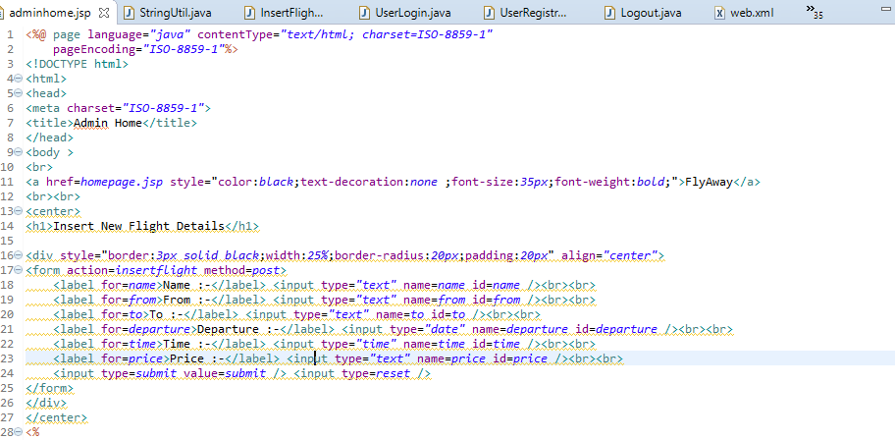

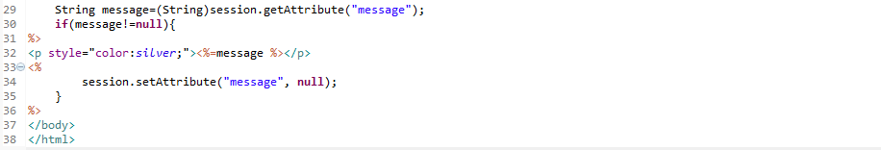

**Adminpage.jsp**

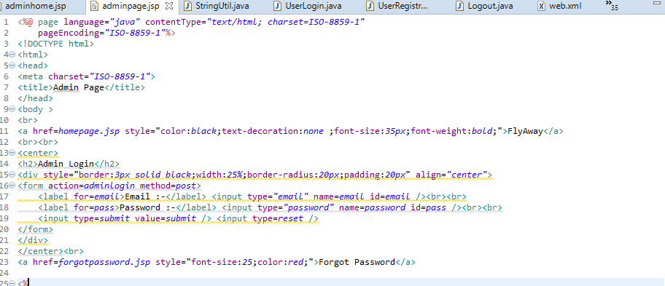

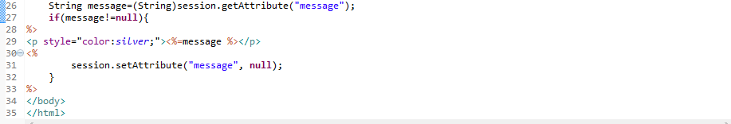

**bookflight.jsp**

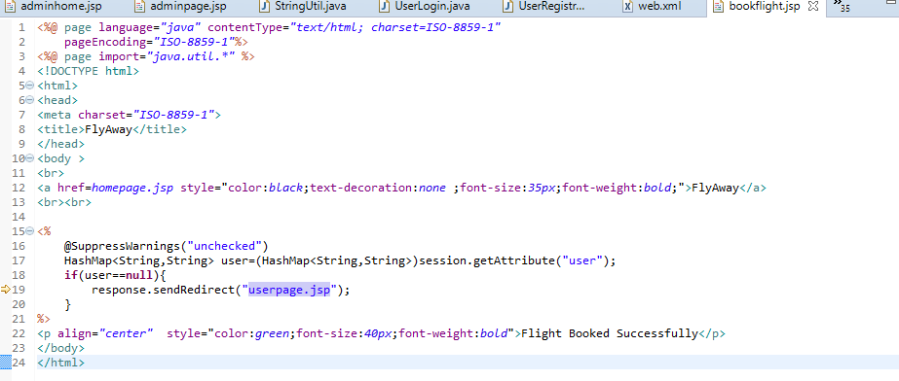

**flightlist.jsp**

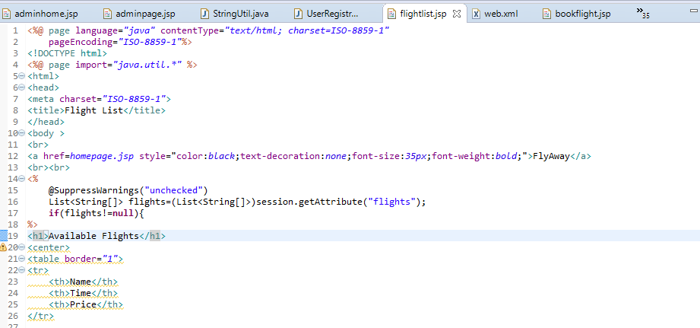

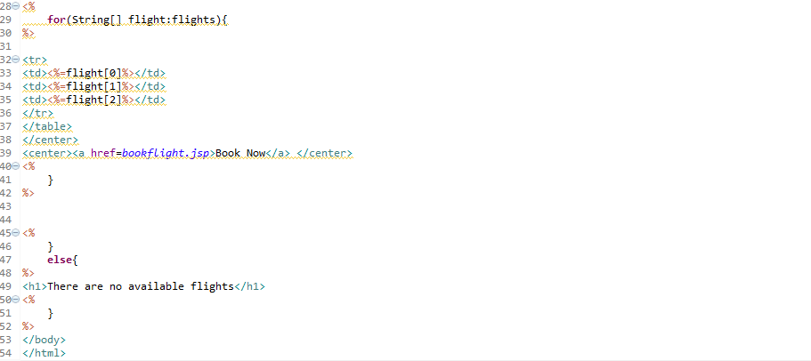

**forgotpassword.jsp**

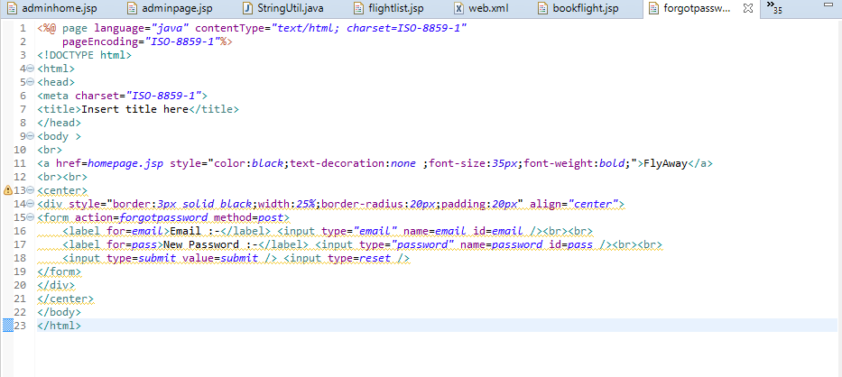

**homepage.jsp**

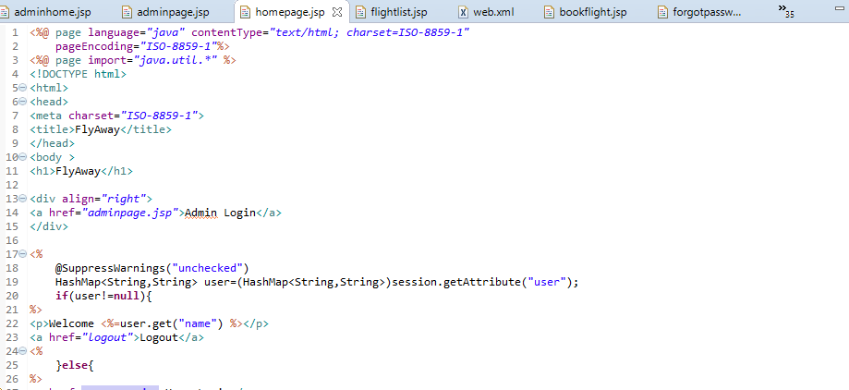

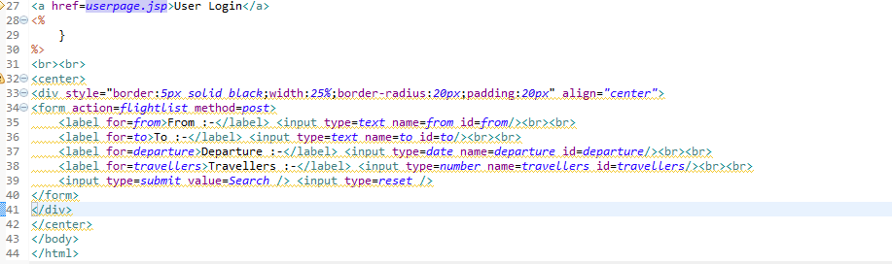

**userpage.jsp**

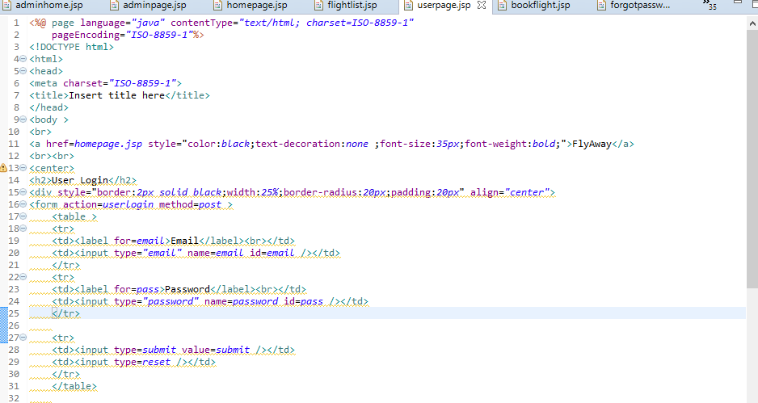

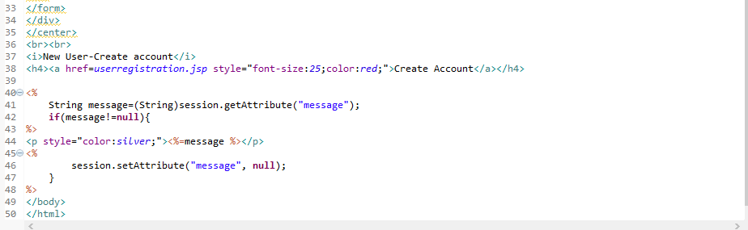

**userregistration.jsp**

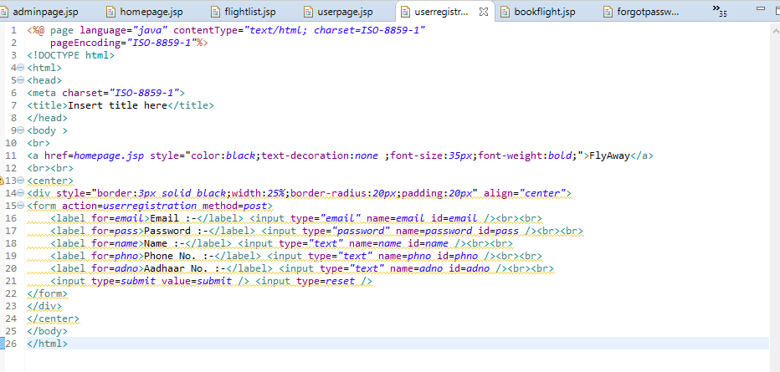

**Outputs- Screenshots:-**

**HomePage to login the user to FlyAway Appplication**

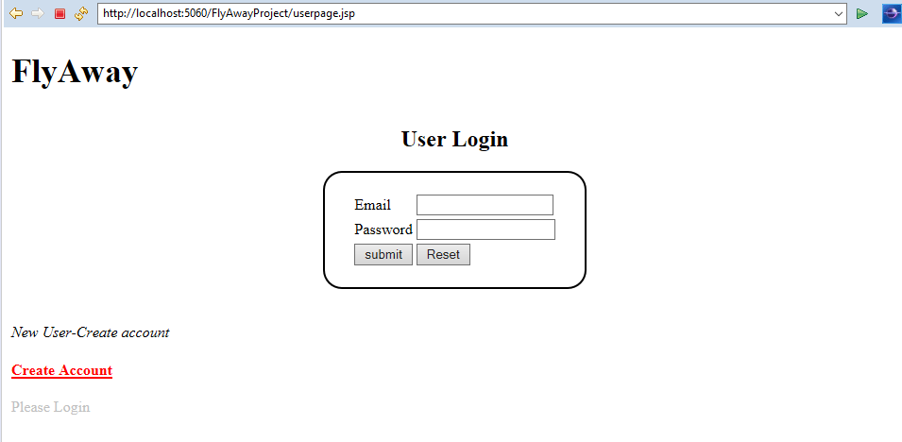

**If First time user 🡪 click on New-User-Create account**

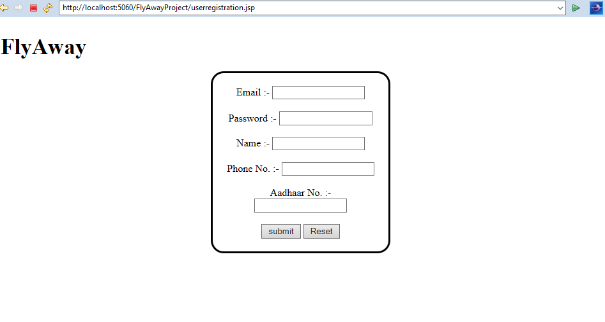

**Provide User Detials and click on submit button**

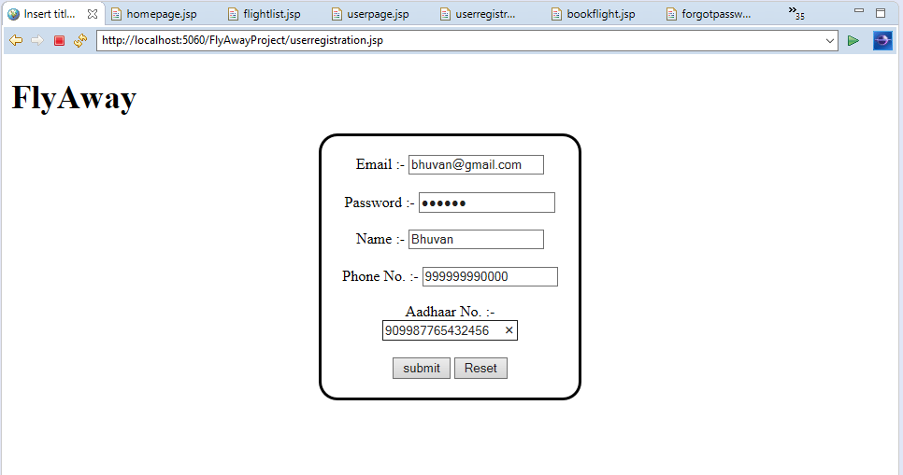

**After successfully saving the data of user-showing user added successfully**

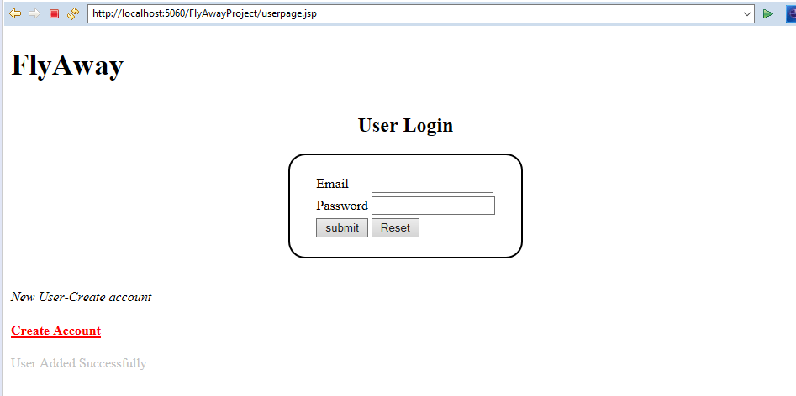

**Provide details for Login –Email and password**

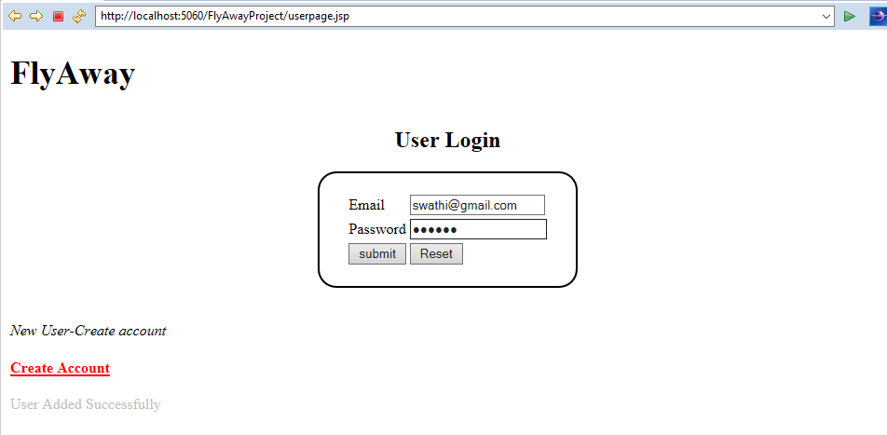

**After submitting the details successfully click on submit button and it display search flight page**

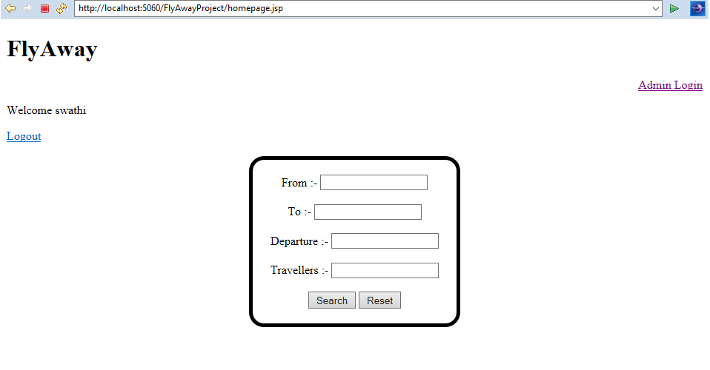

**Provide all the details and click on search button**

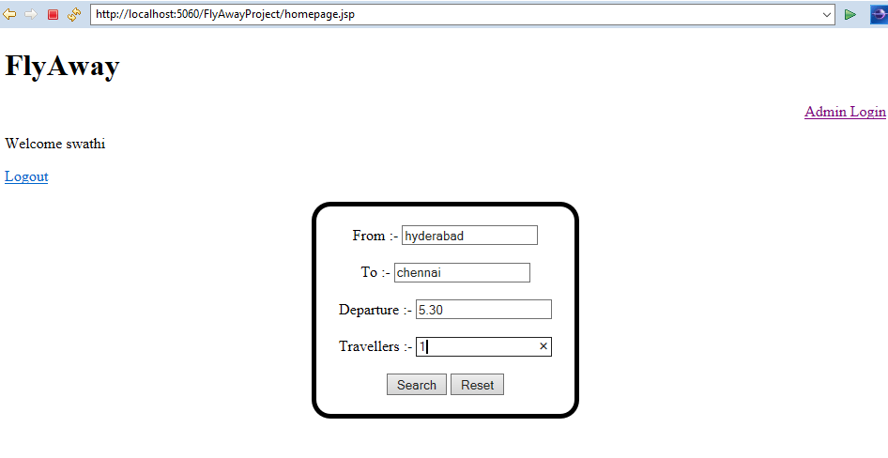

**If Flight not available it display’s as there are no flights available**

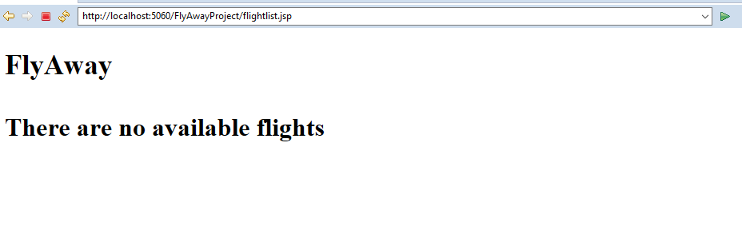

**If Flight available it display’s the available flights and click on Book Now to book the flight**

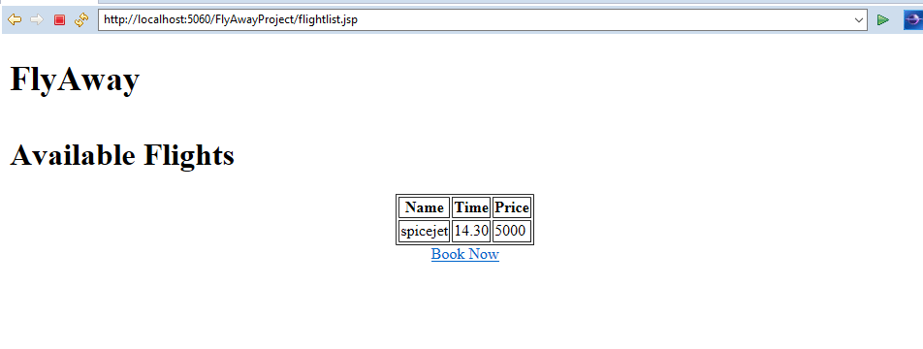

**Click on Book now and it display as Flight Booked Successfully**

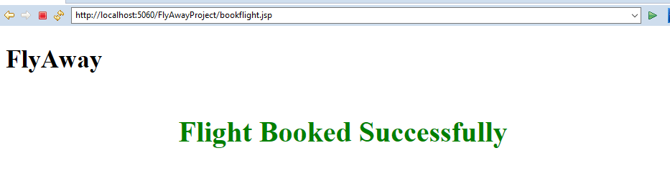

**Click on Admin login to login as a Admin**

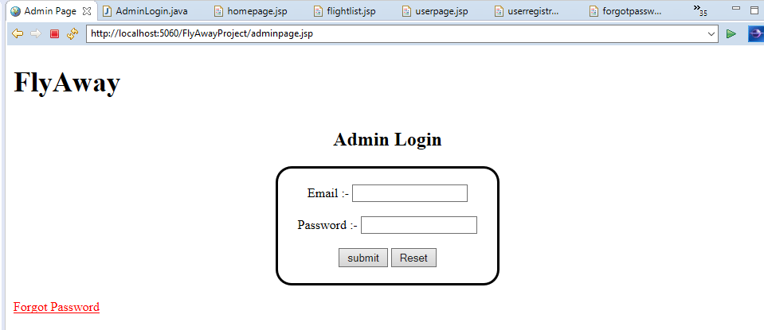

**Provide the login details and click on submit button**

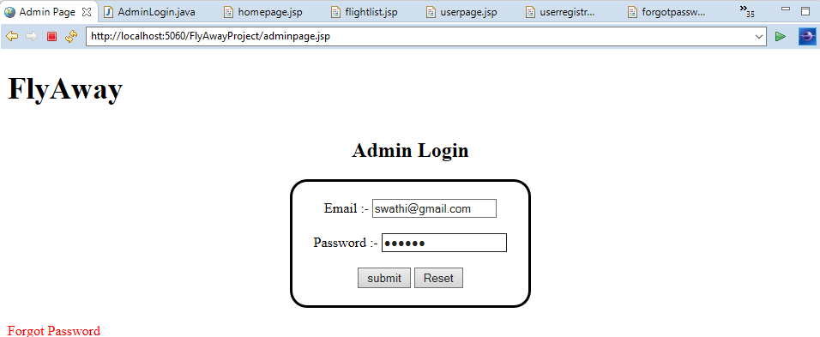

**After successful login it will Display Filght form to add New Flight Details**

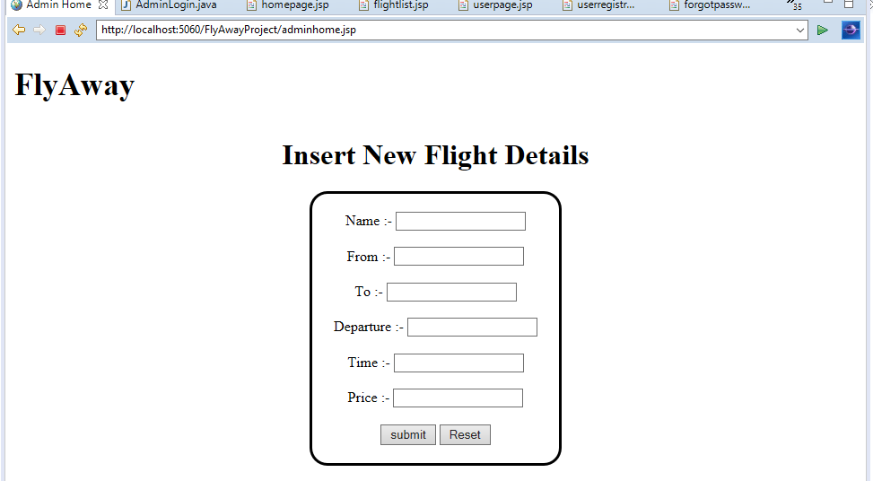

**Provide the flight details and click on submit button**

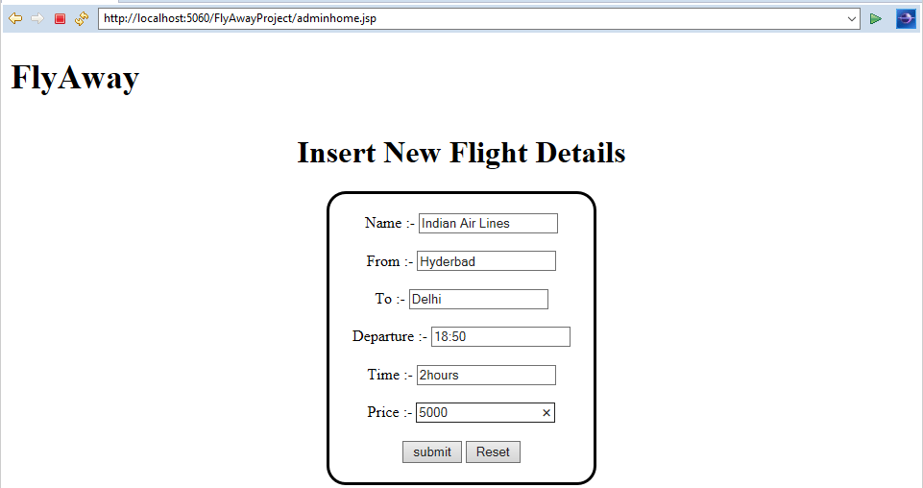

**After successful registration it shows flight added successfully**

